1. 1. From *Networks, Crowds, and Markets: Reasoning about a Highly Connected World*: “We say that an edge joining two nodes A and B in a graph is a local bridge if its endpoints A and B have no friends in common — in other words, if deleting the edge would increase the distance between A and B to a value strictly more than two”

Because the span is the distance between two nodes if the local bridge between them didn’t exist, an edge is only a local bridge if it increases the distance between A and B to a value more than 2, and the distance between A and B must be an integer value, **the minimum possible value of the span of a local bridge is 3**.

* 1. Claim 1: If strong triadic closure is satisfied then local bridges between nodes with at least one other existing strong tie are weak ties.

If Claim 1 is assumed false, then strong triadic closure can be satisfied with a strong tie acting as a local bridge with a node that has at least one other weak tie. This can be seen below:

Strong tie and local bridge

Strong

tie

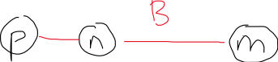

Claim one says that strong triadic closure is satisfied and also that B is a local bridge, however for edge B to be a local bridge, nodes m and p cannot be connected. Node P and m must be connected to adhere to strong triadic closure because node n has a strong tie to each of them.



Because nodes p and m cannot simultaneous be connected and not connected, the assumption that Claim 1 is false must be wrong and Claim 1 must be true.

1. 1. The network is not balanced because if you looked at the relationships between 1 member of each village, you would have 3 nodes, but each edge would be negative because each person would be enemies with the two people from the other villages.

I would predict that 2 of the villages would become friends (because the enemy of an enemy is a friend) and they would remain enemies with the other village.

* 1. Because this is a balanced network, the nodes can be divided into 2 groups. The first group, $X$, has $a$ and all of node its friends ( $k+1$ nodes). The second group, $Y$, has the remaining $n-k-1$ nodes. Due to the Balance Theorem, all nodes in $X$ are friends, all nodes in $Y$ are friends, and all nodes in $X$ are enemies with all nodes in $Y$. The only combination of nodes that are enemies, are when there is one node from $X$ and one node from .

1. 1. See Repository homework-2-kinaanpatel_terrylu

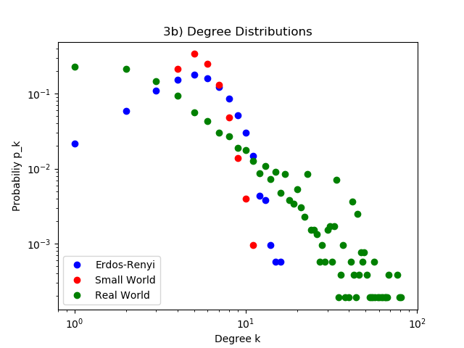

* + 1. Degree distribution of real world collaboration network has more nodes with higher degree than random graph.



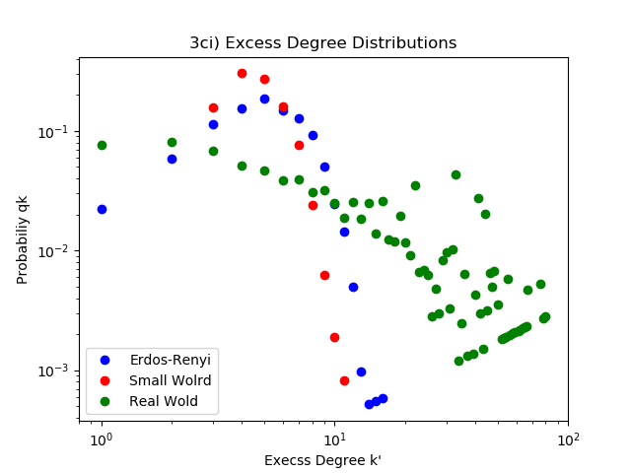

* + 1. There is higher probability for the collaboration graph to have higher excess degree compared to degree.

The expected excess degree of Eros-Renyi graph is 5.52

The expected excess degree of Small World graph is 4.81

The expected excess degree of Real World graph is 15.87

* + 1. To compute The probability of a random chosen edge leads us to a node with degree k+1, the edge must be connected to one of n*pk+1 nodes that have a degree of k+1. And weigh it by the edges, we get qk = (k+1)/(2m) * n*pk+1
  1. 1. Repository Name: homework-2-kinaanpatel_terrylu

The average clustering coefficient of Eros-Renyi graph is 0.001041

The average clustering coefficient of Small World graph is 0.284092

The average clustering coefficient of Real World graph is 0.529636

* + 1. The Real World graph has the largest clustering coefficient. Because in real world, the authors work more closely together, and instead of collaborating with random authors, they all tend to collaborate much more with more knowledgeable authors, creating a larger cluster hence a larger clustering coefficient.